Topology Qualification Exam, Fall 2021

Instructions
- Please work on 8 out of 9 problems, and clearly mark which one you do not want us to grade.
- You can assume homology groups and fundamental groups of a point and wedges of spheres in all dimensions. Everything else should be computed.

Problems
- Prove or disprove the following:
  - If $X$ and $Y$ are path-connected, then $X×Y$ is path-connected.
  - If $A⊂X$ is path-connected, then its closure $\overset{‾}{A}$ is path-connected.
- Let $S$ be a connected metric space with metric $d$. Given $p∈S$, show that if $S\backslash \{p\}≠∅$ then $S\backslash \{p\}$ is not compact.
- Give an example of a continuous map $f:X→Y$ between connected spaces that is a continuous bijection but not a homeomorphism.

  - Compute fundamental groups of $T^{3}$ and $RP^{3}$ (Hint: construct their universal covers.).
  - Prove there is no covering map from $T^{3}$ to $RP^{3}$.
- Let $Σ_{g}$ denote the surface of genus $g$.
  - Suppose there is a degree $n$ covering map $f:Σ_{g}→Σ_{h}$. What is the relationship between $g$, $h$ and $n$?
  - Show that there is no finite covering map from $Σ_{g+1}$ to $Σ_{g}$ for $g>2$.
- Let $X$ be the topological space obtained from the Klein bottle $K$ by removing a small open disk and identifying antipodal points of the resulting boundary circle on $K$ as in the following figure.
- 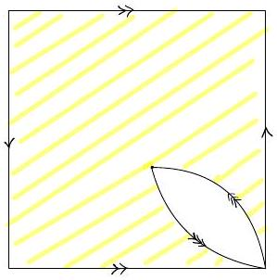
  - Use Van Kampen's theorem to find a presentation for $π_{1}(X)$.
  - Compute the homology groups using cellular homology.
- Let $X$ be the topological space obtained by gluing the boundary of a disk to a torus along a figure eight shape curve as in the following figure. Use the Mayer-Vietoris sequence to compute the homology groups of $X$.
- 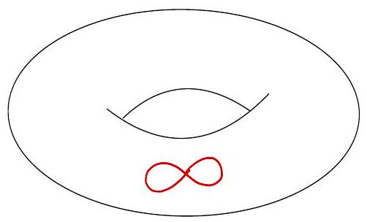

  - Compute the homology groups of $X=S^{2}×S^{4}$ and $Y=CP^{2}∨S^{6}$.
  - Show that $X$ and $Y$ are not homeomorphic.
- Consider the torus $T$ in $R^{3}$ obtained by revolving the circle $(y-2)^{2}+z^{2}=1$ in the $yz$-plane around the $z$-axis. Let $i$ be the map induced by ${180}^{∘}$-rotation around the $y$-axis on this torus i.e.,
$$i(x,y,z)=(-x,y,-z)$$
  - Find a cell structure on $T$ such that $i$ maps cells to cells.
  - The quotient of $T$ with the relation $x∼i(x)$ for all $x∈T$ is an orientable surface (you do not need to show this, you can take this as given). Find the genus of this surface.

